By Default hosts file is in /etc/ansible/hosts

We can create our own file at any location in order to maintain project isolation, while running playbook we need to give that.

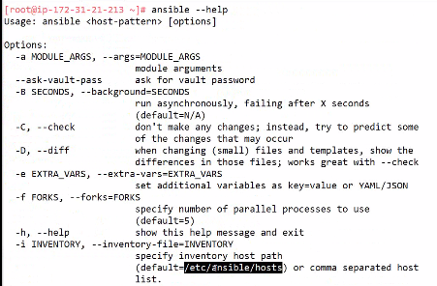

To list the available hosts



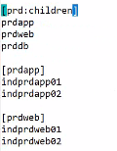groups and child groups  
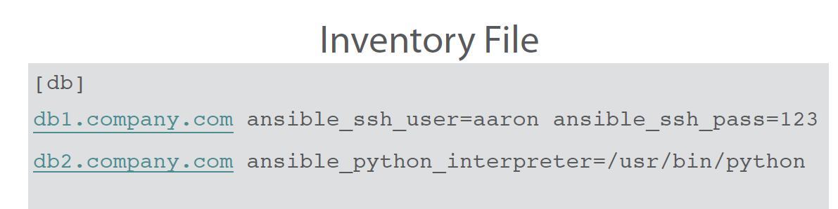

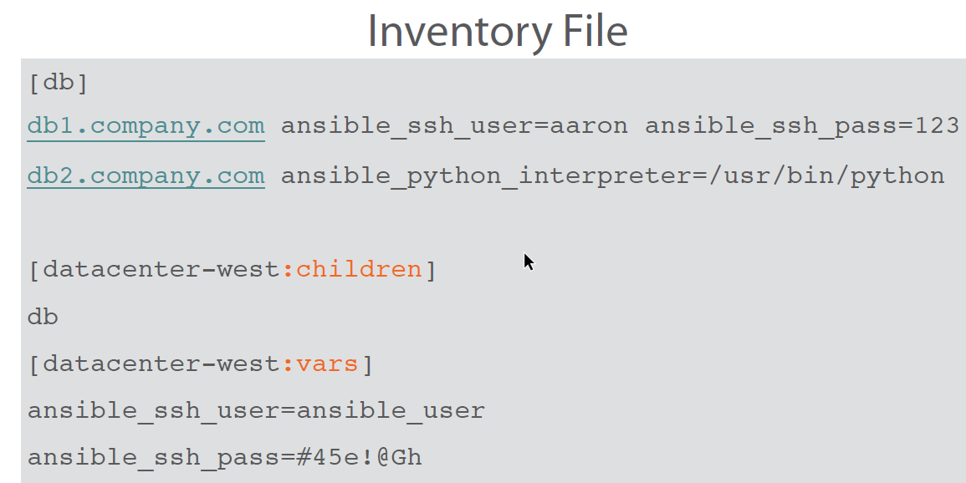

Connecting to AWS:



Config Files:

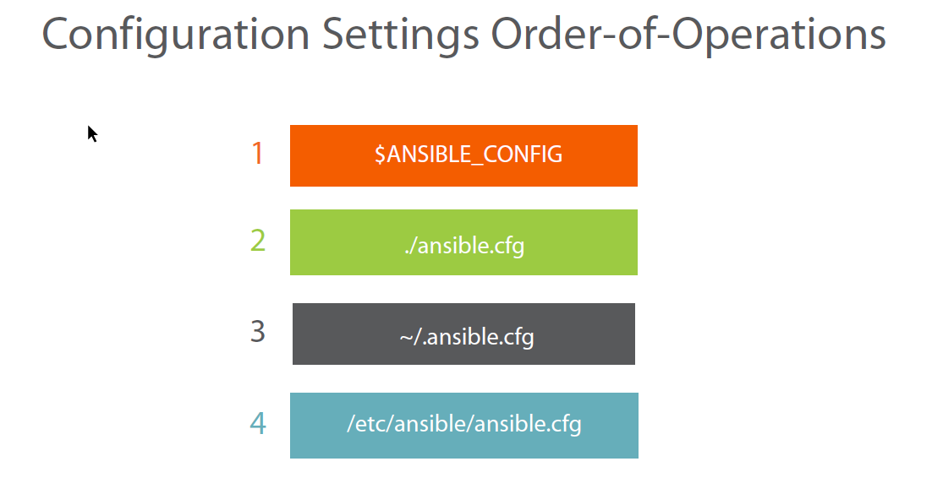

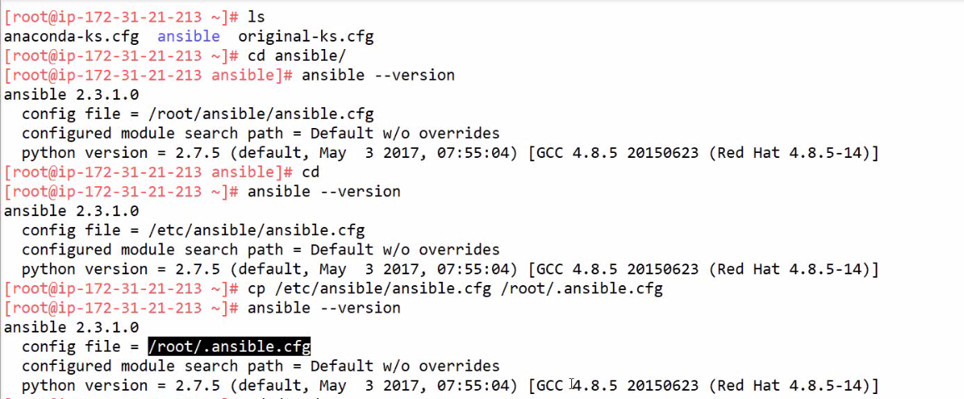

Local 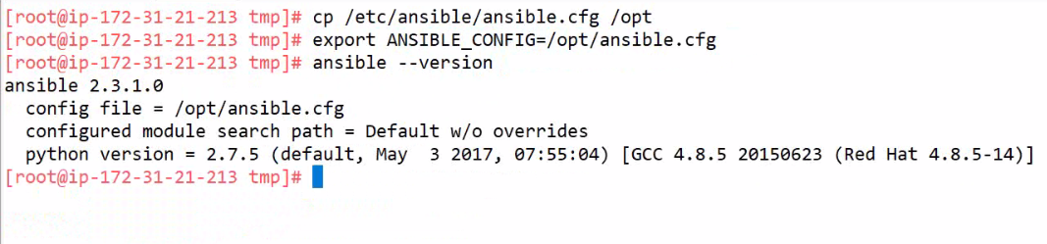

Priority :

First variable, next root/home, next folder and finally /etc/ansible.

**Command:**

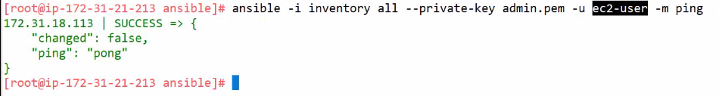

Rather than giving all the list of inputs, we can configure these in ansible-cfg file.

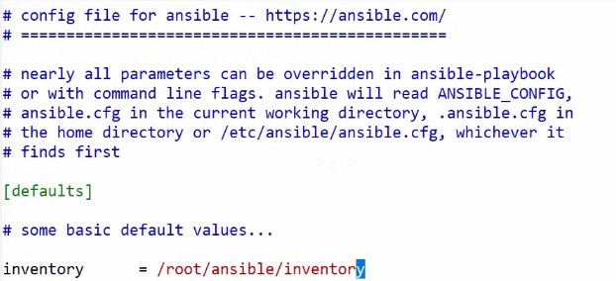

The command now works without mentioning inventory

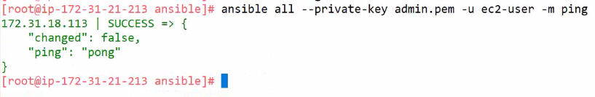

Check the below one for Private Key.

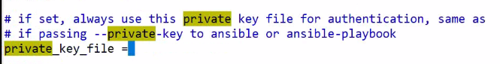

To update user

